# Ex No: 7 BUILD AUTOENCODERS

**AIM:**

To build autoencoders with Keras/TensorFlow.

# PROCEDURE:

1. Download and load the dataset.
2. Perform analysis and preprocessing of the dataset.
3. Build a simple neural network model using Keras/TensorFlow.
4. Compile and fit the model.
5. Perform prediction with the test dataset.
6. Calculate performance metrics.

# PROGRAM:

#import tensorflow.keras as keras

from tensorflow.keras.datasets import mnist

from tensorflow.keras.layers import Dense, Input, Flatten,Reshape, LeakyReLU as LR,Activation,

Dropout

from tensorflow.keras.models import Model, Sequential from matplotlib import pyplot as plt

from IPython import display # If using IPython, Colab or Jupyter import numpy as np

(x_train, y_train), (x_test, y_test) = mnist.load_data() x_train = x_train/255.0

x_test = x_test/255.0

# Plot image data from x_train plt.imshow(x_train[0], cmap = "gray") plt.show()

LATENT_SIZE = 32

encoder = Sequential([

Flatten(input_shape = (28, 28)), Dense(512),

LR(),

Dropout(0.5), Dense(256), LR(),

Dropout(0.5), Dense(128), LR(),

Dropout(0.5), Dense(64), LR(),

Dropout(0.5), Dense(LATENT_SIZE), LR()

])

decoder = Sequential([

Dense(64, input_shape = (LATENT_SIZE,)), LR(),

Dropout(0.5), Dense(128), LR(),

Dropout(0.5), Dense(256), LR(),

Dropout(0.5), Dense(512), LR(),

Dropout(0.5), Dense(784), Activation("sigmoid"),

Reshape((28, 28))

])

img = Input(shape = (28, 28)) latent_vector = encoder(img) output = decoder(latent_vector)

model = Model(inputs = img, outputs = output) model.compile("nadam", loss = "binary_crossentropy")

EPOCHS=15

for epoch in range(EPOCHS): fig, axs = plt.subplots(4, 4)

rand = x_test[np.random.randint(0, 10000, 16)].reshape((4, 4, 1, 28, 28)) display.clear_output() # If you imported display from IPython

for i in range(4):

for j in range(4):

axs[i, j].imshow(model.predict(rand[i, j])[0], cmap = "gray") axs[i, j].axis("off")

plt.subplots_adjust(wspace = 0, hspace = 0) plt.show()

print("-----------", "EPOCH", epoch, " ")

model.fit(x_train, x_train)

# OUTPUT:

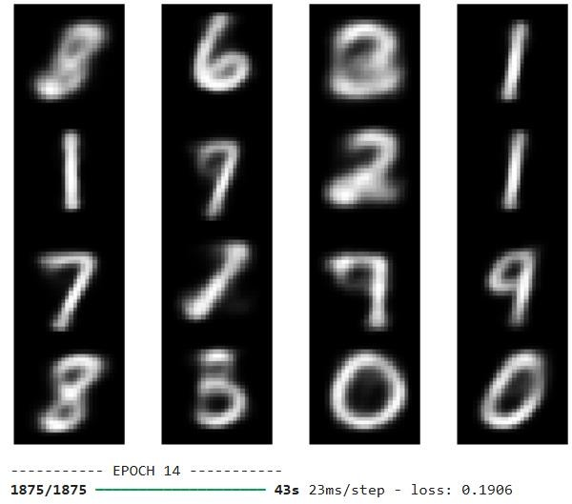

**RESULT:**

Thus autoencoders with Keras/TensorFlow are built.